Hampden Ave. to Colorado Boulevard Section
Detour Descriptions:
Northbound: Exit the High Line Canal Trail at Colorado Blvd. and continue north on the bike path alongside Colorado Blvd. After approximately 0.7 miles, turn left onto the paved path on the north side of E. Jefferson Ave. Turn right (north) onto Monroe St.; just before it meets Hampden Ave., turn left onto the small path that runs parallel to Hampden. This path will lead you downhill to the underpass to cross beneath Hampden Ave. and head north into Denver.
Southbound: Trail users should exit the High Line by coming up the hill from the underpass and turning north (right) onto the small sidepath that runs parallel to Hampden Ave. This path will meet Monroe St. Turn south (right) onto Monroe, which deadends at E. Jefferson Ave. Turn left to take the paved path on the north side of Jefferson Ave. east to meet Colorado Blvd. Turn right to follow the bike path alongside Colorado Blvd for approximately 0.7 miles. Rejoin the High Line Canal Trail where it crosses Colorado Blvd. and continues east into Three Pond Park.
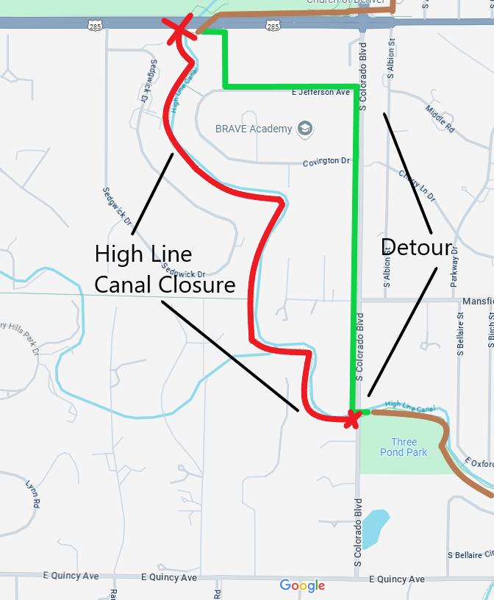

Colorado Boulevard to Quincy Ave. Section
Detour Descriptions:
Northbound: From the closure at Quincy Ave., turn left on the Quincy Ave. bike path. At Colorado Boulevard, turn right to take the bike path north for approximately one-third of a mile. Rejoin the High Line Canal trail where it crosses Colorado Blvd. (turn left to continue traveling north).
Southbound: From the closure at Colorado Blvd., turn right to take the bike path south along Colorado Blvd. It will deadend at Quincy Ave.; cross Quincy and turn left on the paved path that parallels Quincy Ave. Rejoin the High Line Canal trail where it crosses Quincy Ave. (turn right to continue traveling south).
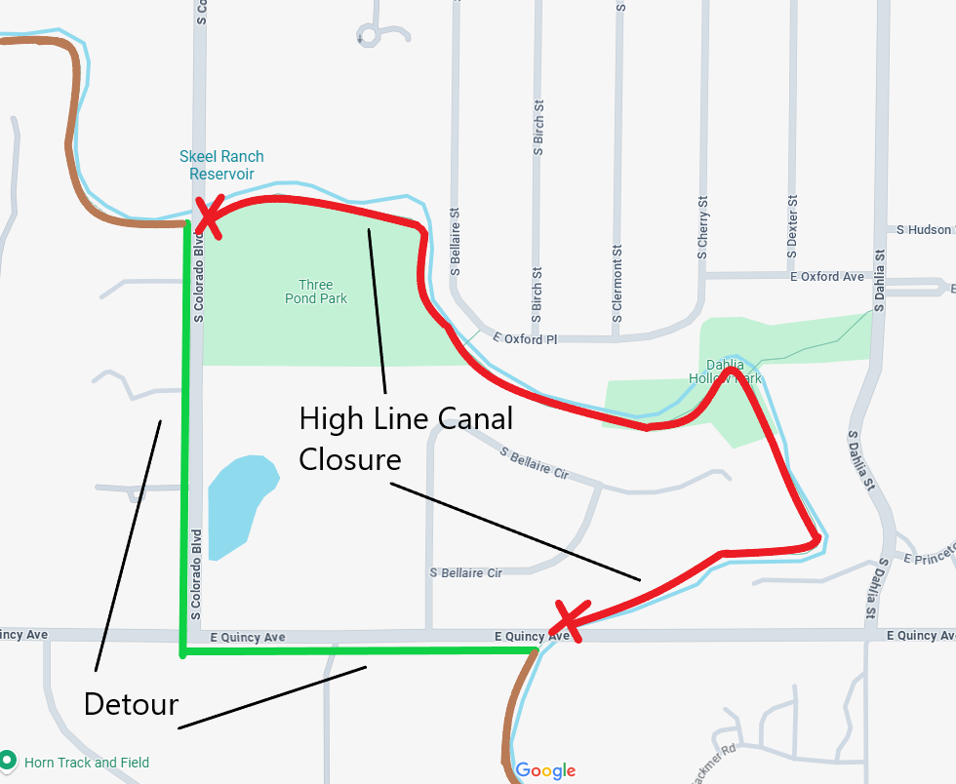

Quincy Ave. to Belleview Section
Detour Descriptions:
Northbound: From the closure Belleview, follow the sidewalk on Belleview east until Holly Street. Turn left (north) on Holly; the sidewalk on the west side of Holly will turn into a paved path. Follow this path until it deadends at Quincy Ave.; turn left to follow the Quincy Ave. bike path. Rejoin the High Line Canal trail where it crosses Quincy Ave. (turn right to continue traveling north).
Southbound: From the closure at Quincy Ave., follow the bike path east along Quincy Ave. When you reach Holly St., turn right to travel south on the paved path that parallels Holly. When you reach Belleview, turn right to follow the sidewalk west along Belleview. When you reach the High Line Canal crossing, turn right (north) onto the High Line briefly in order to drop down to the underpass (path will be on your left). Cross under the underpass to continue south into Greenwood Village.
